

MenCare Health Hub — Backend Blueprint
Recommended Stack

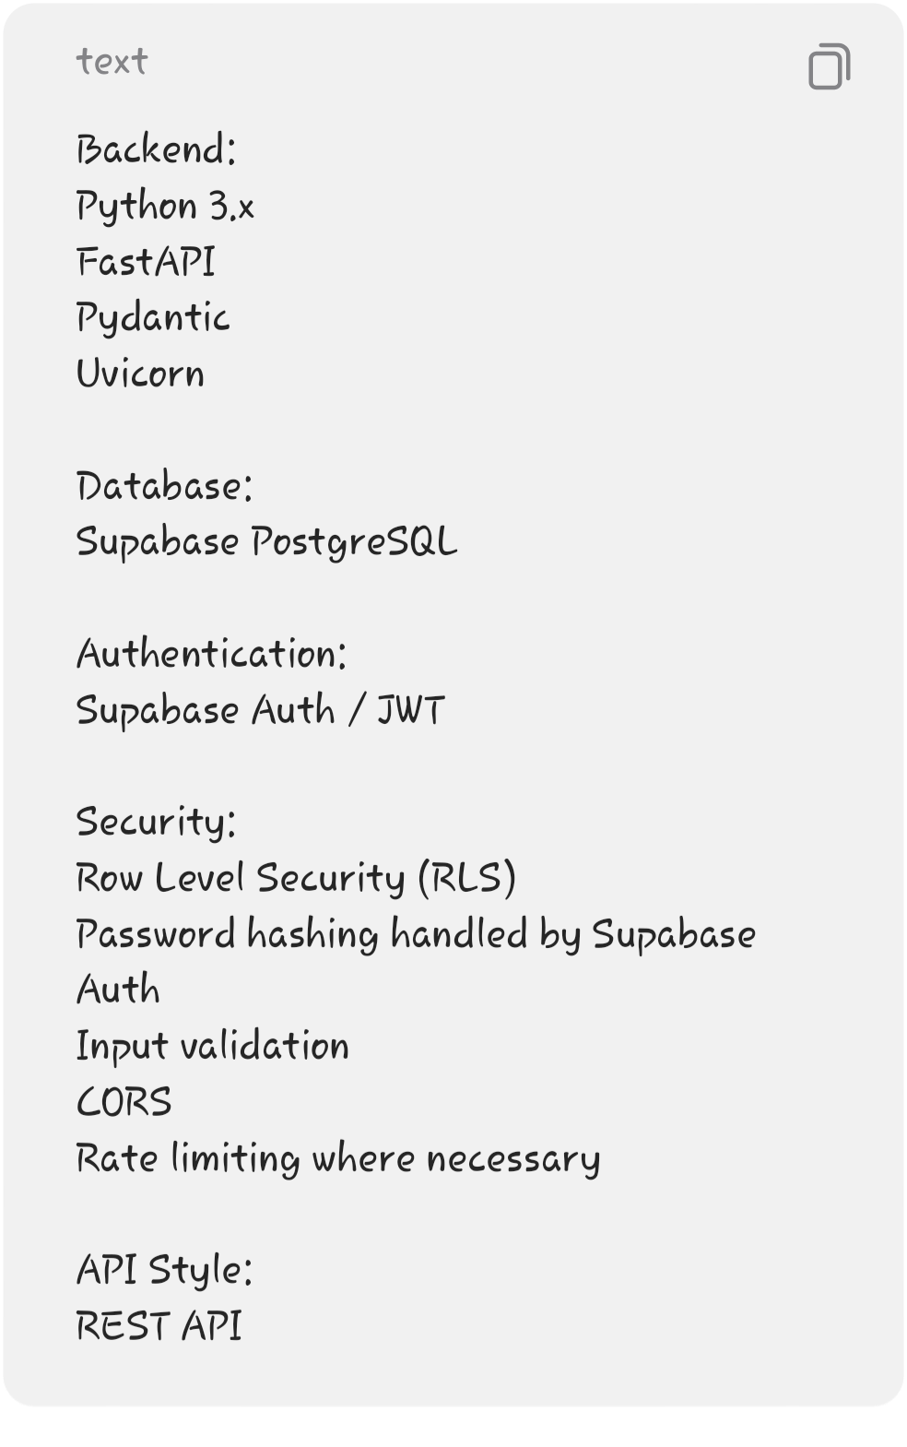

───
1. Backend Architecture
Keep the architecture straightforward:
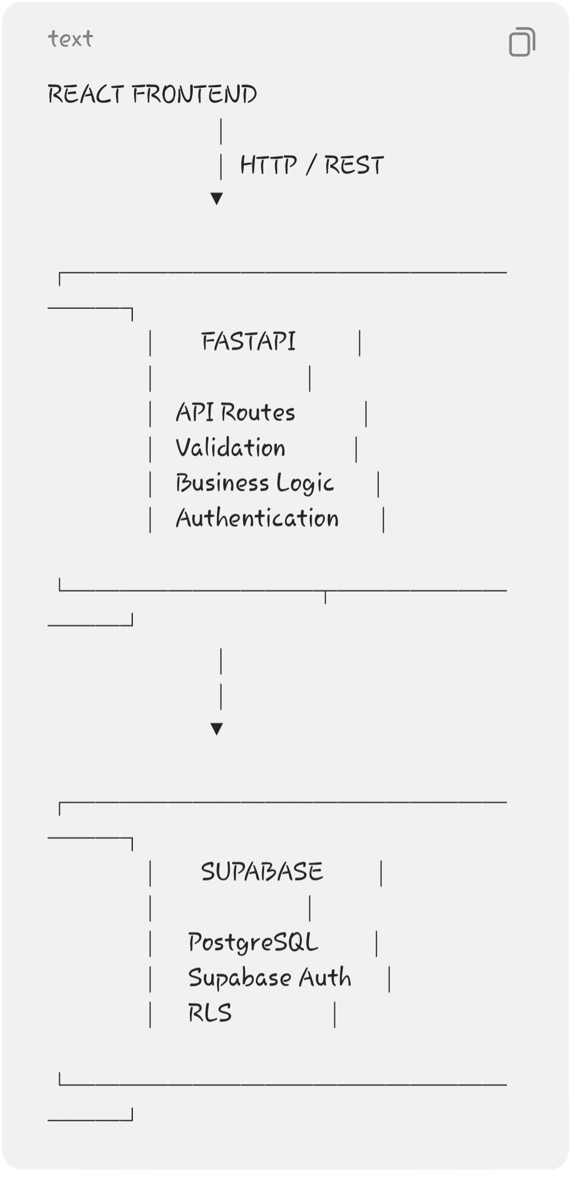
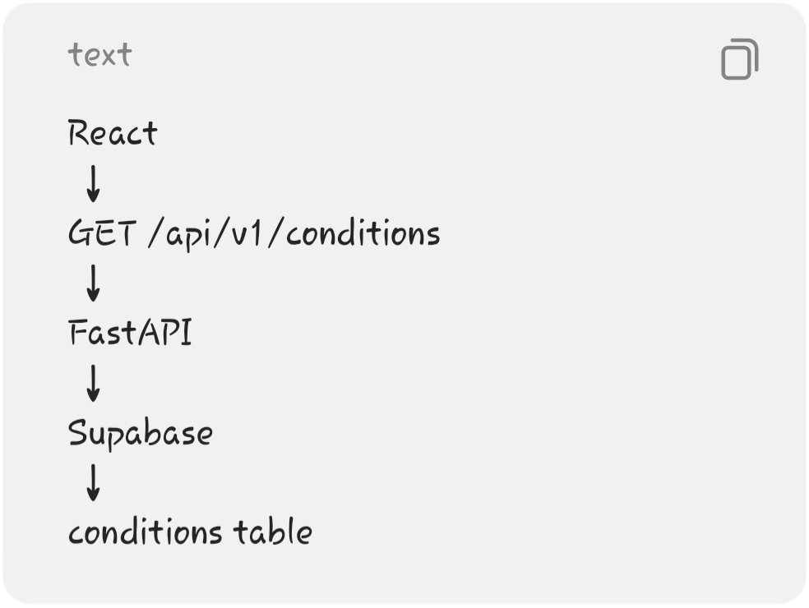
The frontend should not directly contain your business logic.
For example:

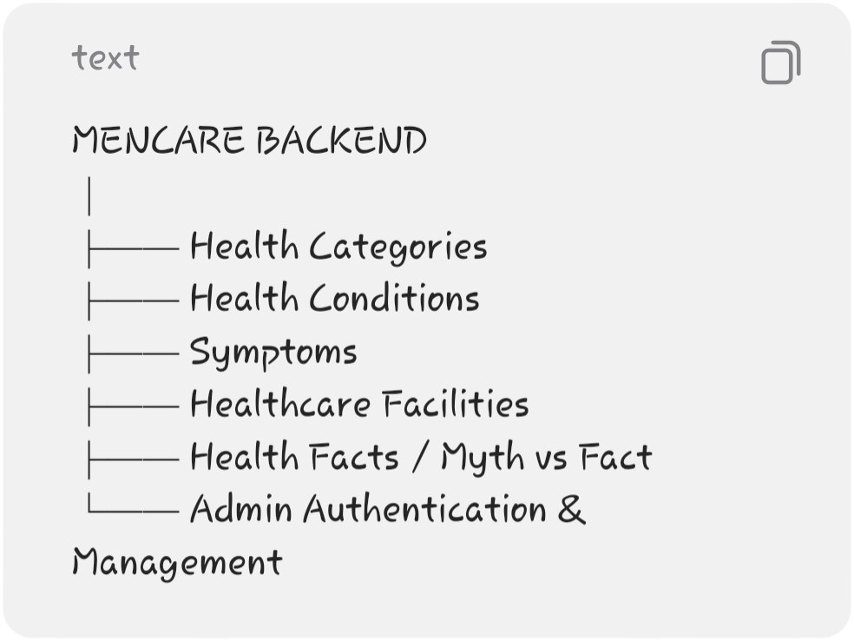

───

2. Main Backend Responsibilities
Your FastAPI backend will handle approximately 6 areas:

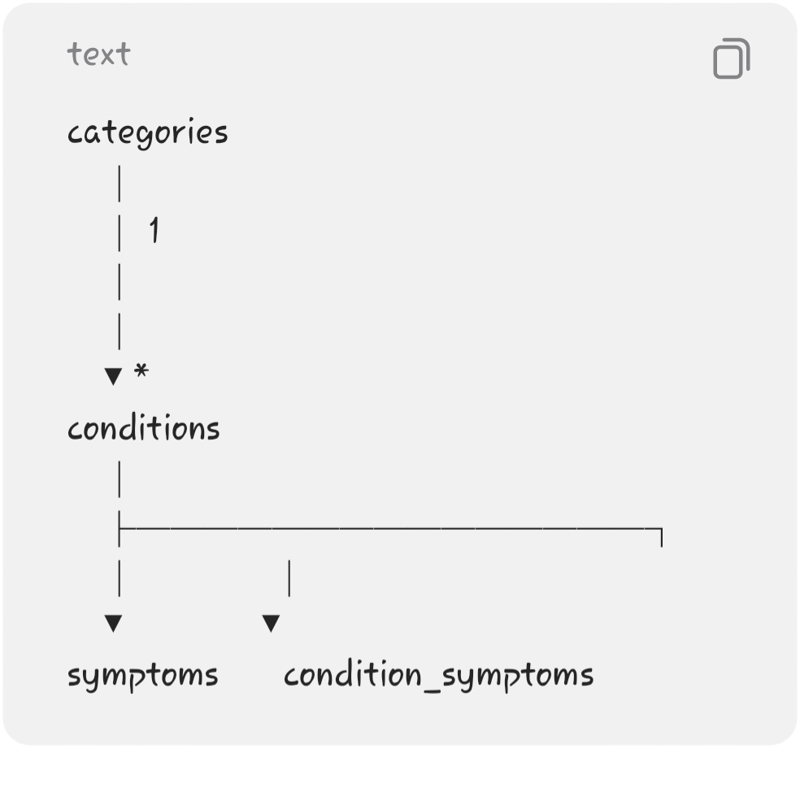
There is no diagnosis engine and no symptom scoring engine.

───

3. Database Design
For the MVP, I recommend around 7 tables.

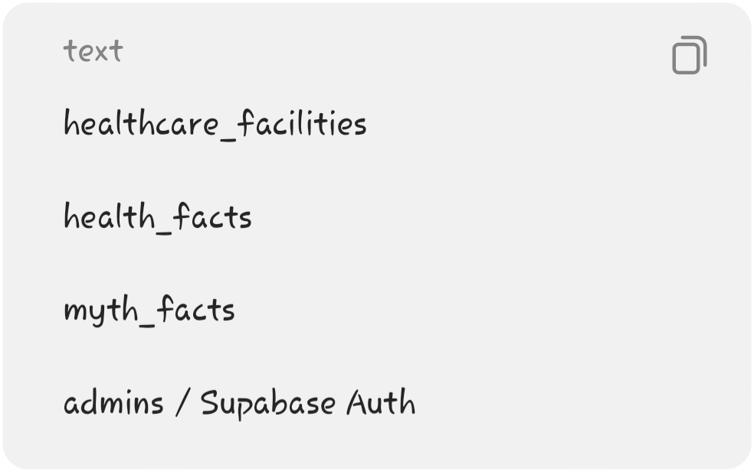
And separately:

You can simplify the symptoms relationship further for the first version, but the above gives you a cleaner database design.

───

4. Categories Table
Stores the major health categories.
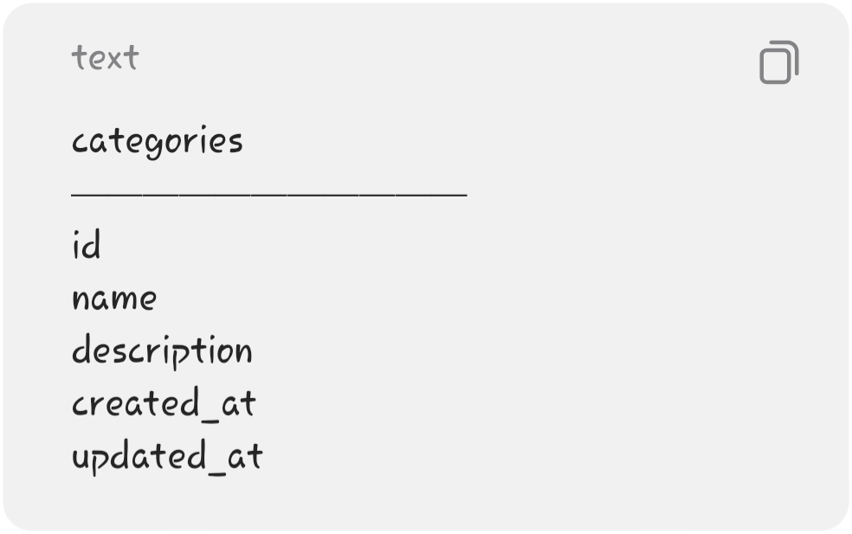
Example:
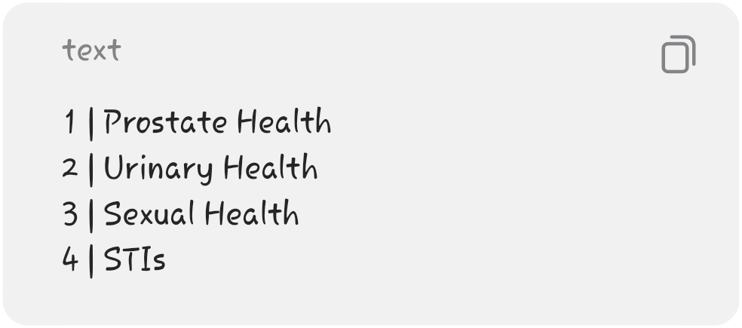
Purpose
Allows the frontend to display:
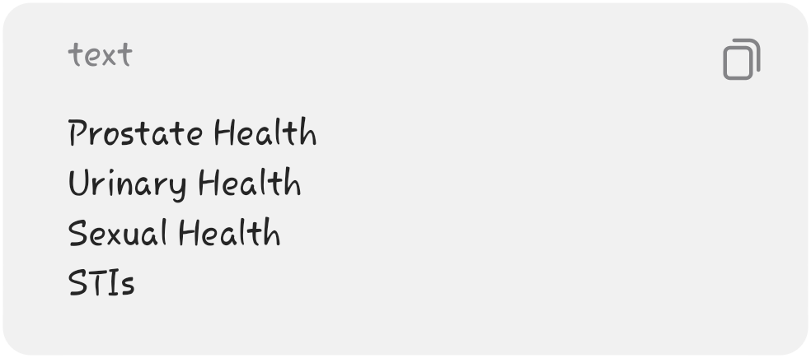
and allows conditions to belong to a category.

───

5. Conditions Table
This is the core table of the educational system.

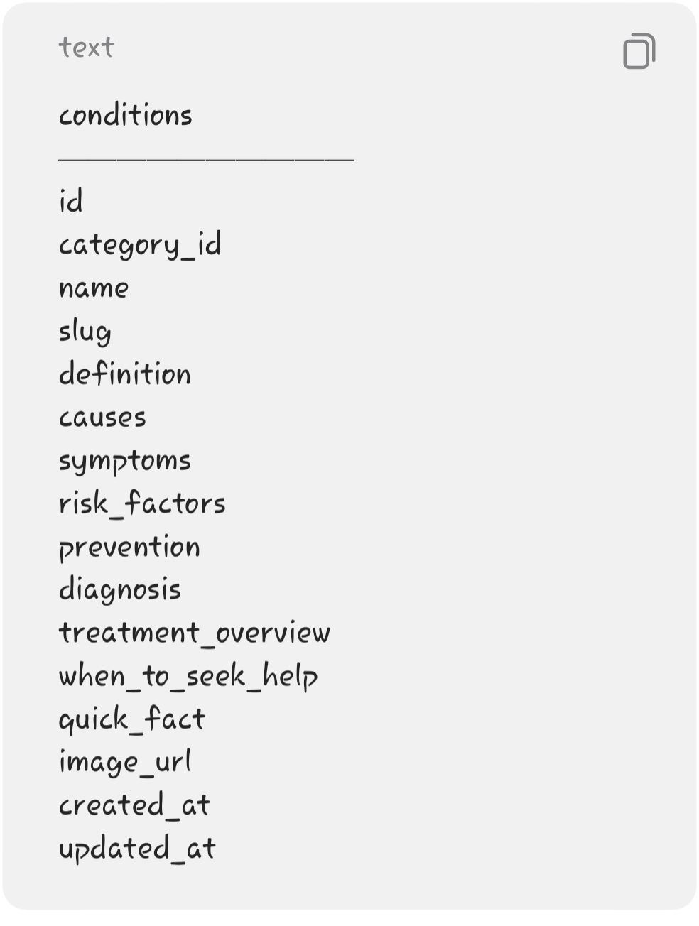
Example:
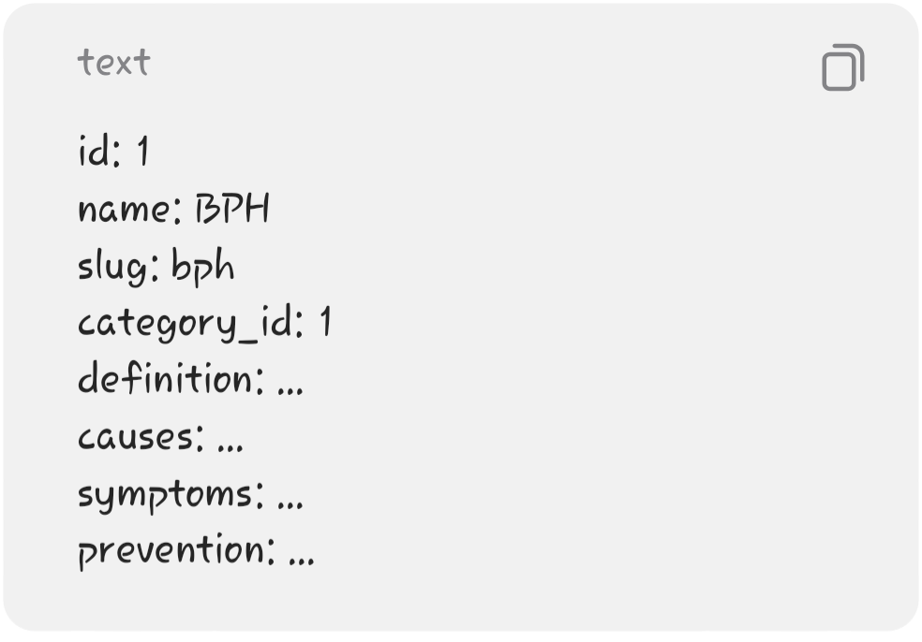
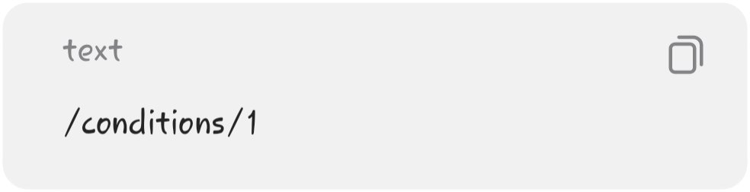
Why use a slug?
Instead of:
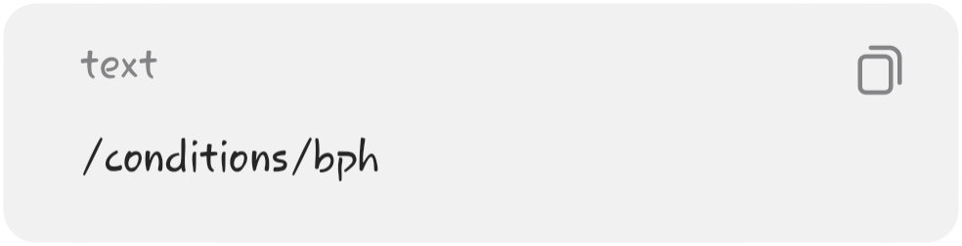
you can eventually have:

which is cleaner for the frontend.

───
6. Symptoms Table
Since you want a symptom awareness page, it makes sense to have symptoms as their own database records.
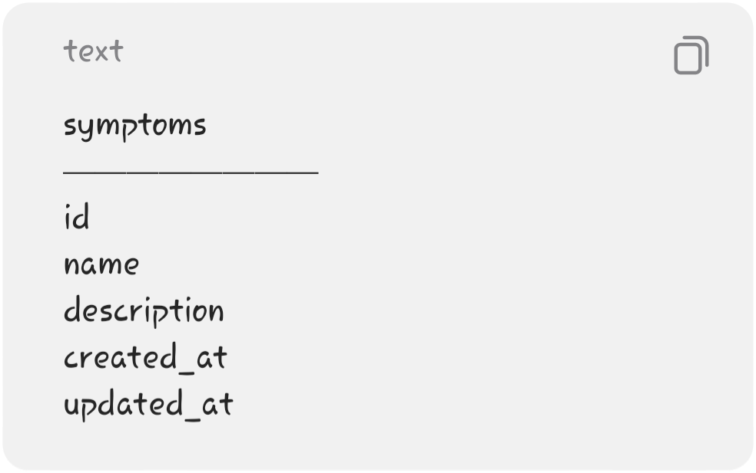
Examples:
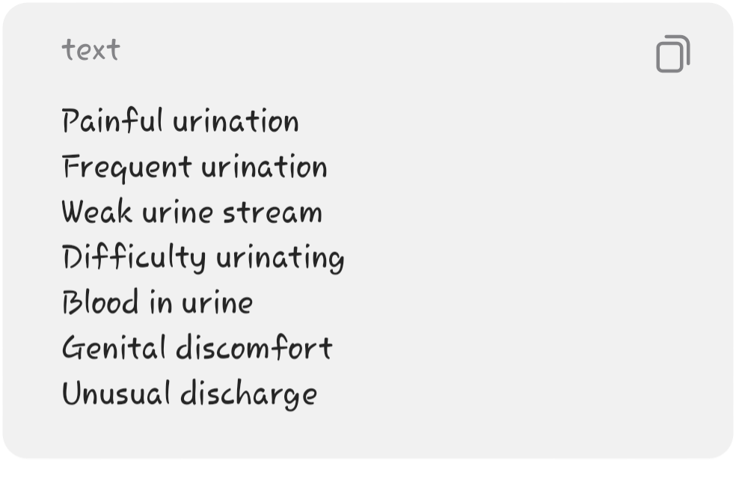
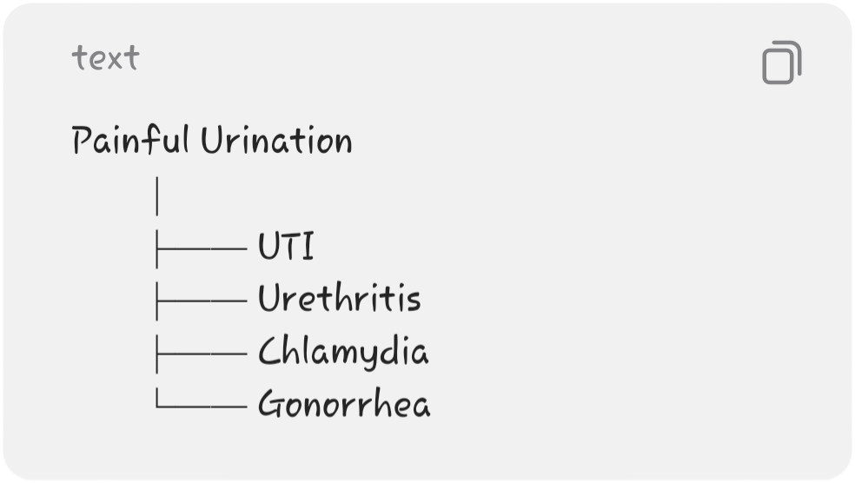

───

7. Condition-Symptom Relationship
A condition can have many symptoms, and a symptom can be associated with multiple conditions.
For example:

Therefore, use:
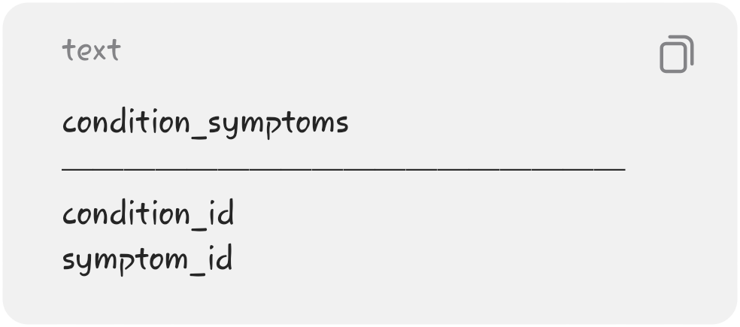
This creates a many-to-many relationship.
This is actually a good database concept to demonstrate in your project defense.

───

8. Healthcare Facilities Table
Stores clinics and hospitals.

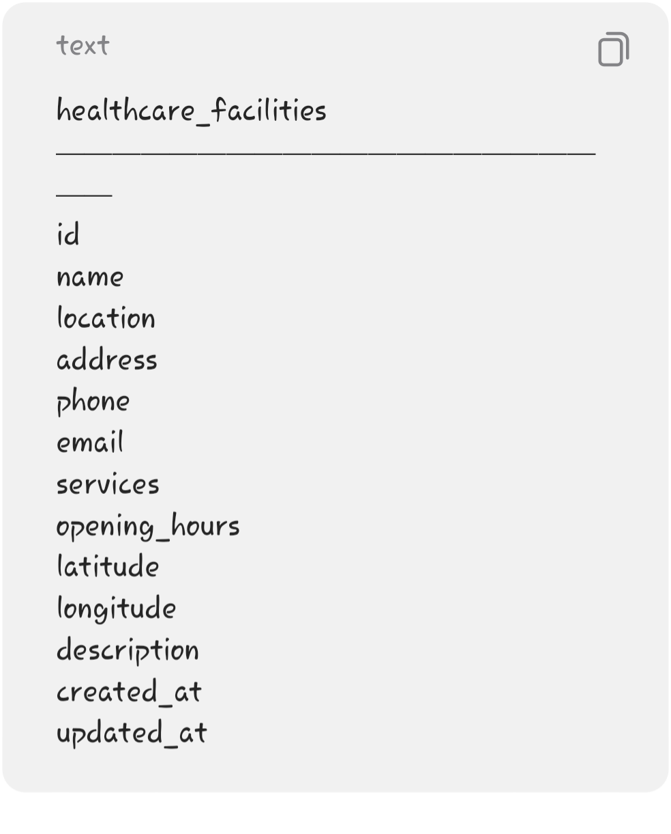
Example:
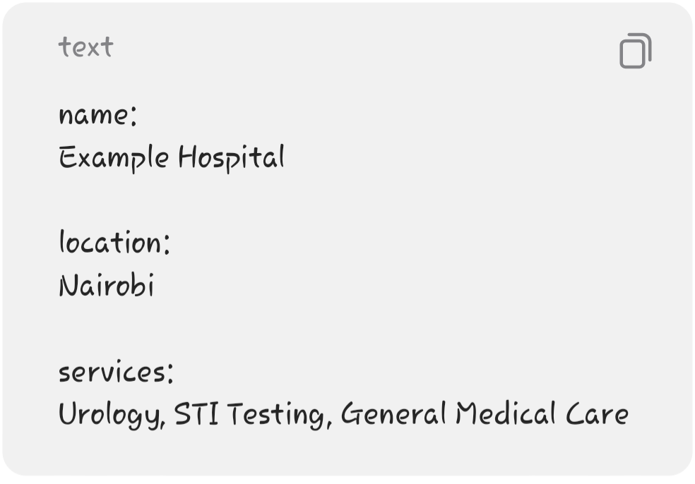
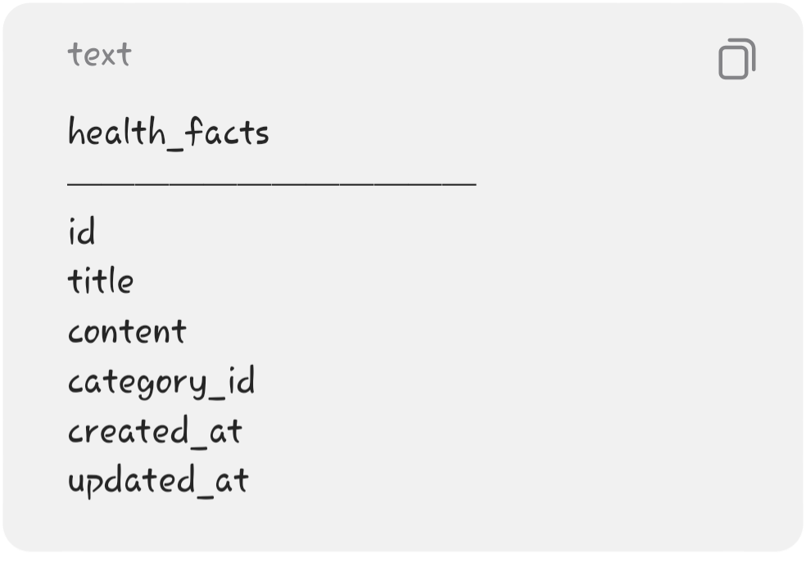
Why latitude and longitude?
They allow the frontend to provide:
Get Directions
later.

───

9. Health Facts Table
Stores quick educational facts.

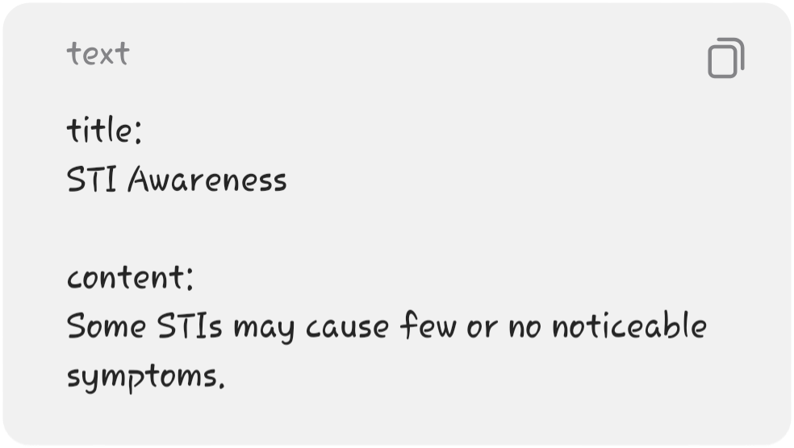
Example:

───

10. Myth vs Fact Table
Stores educational myths and their corrections.
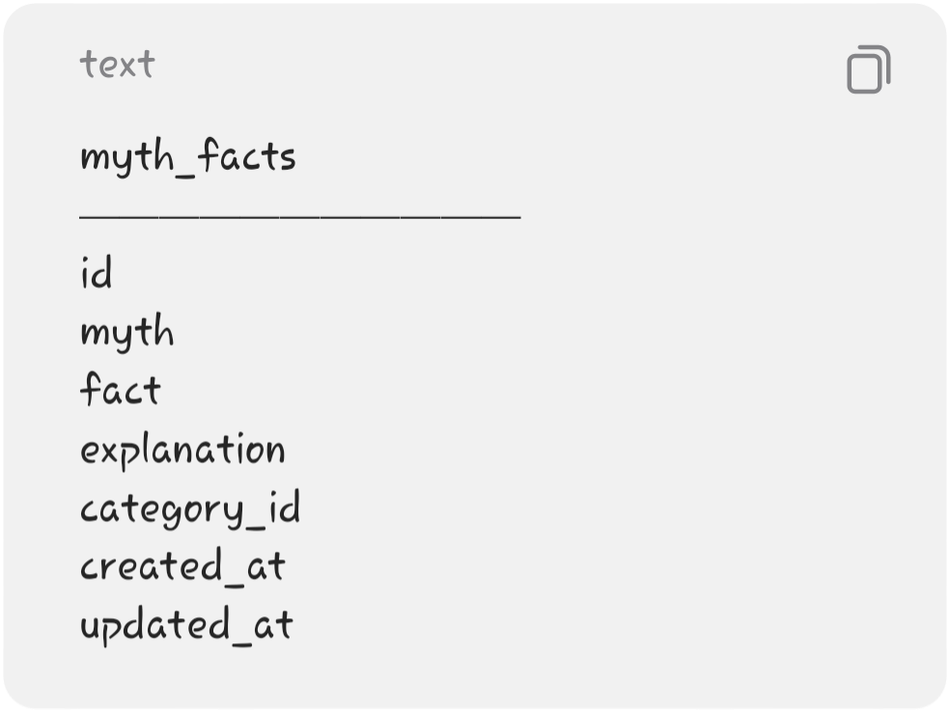
Example:
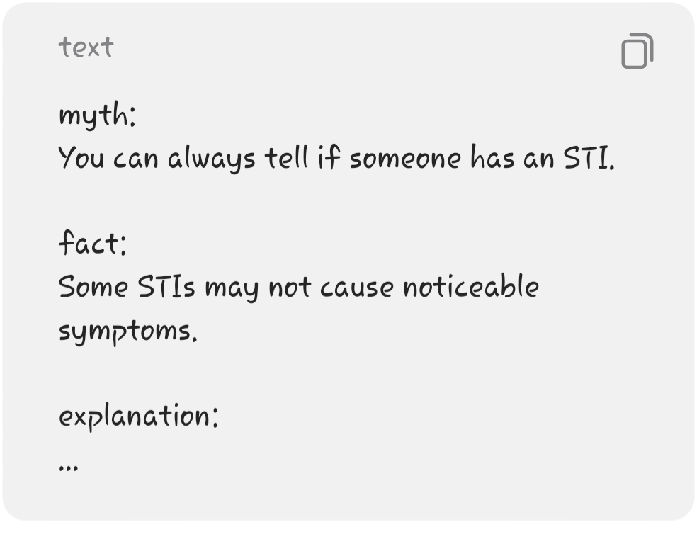

───

11. Admin Authentication
Don't build your own authentication system from scratch.
Use:
Supabase Authentication
The flow becomes:

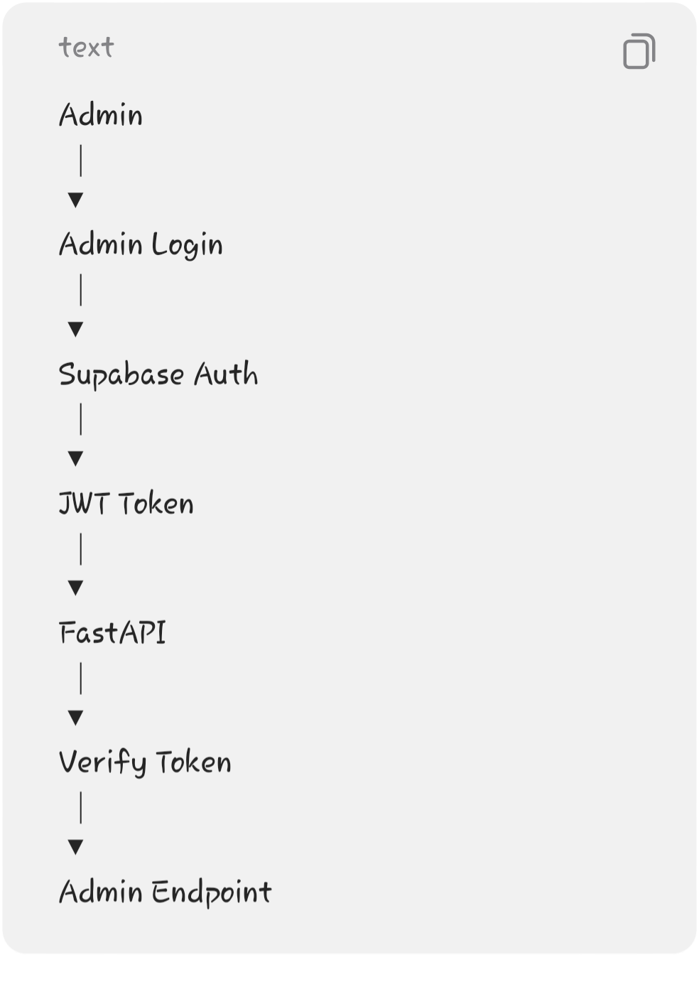
This is much safer and simpler.

───

12. Admin Authorization
Authentication answers:
"Who are you?"
Authorization answers:
"Are you allowed to perform this operation?"
For example:

can be public.
But:
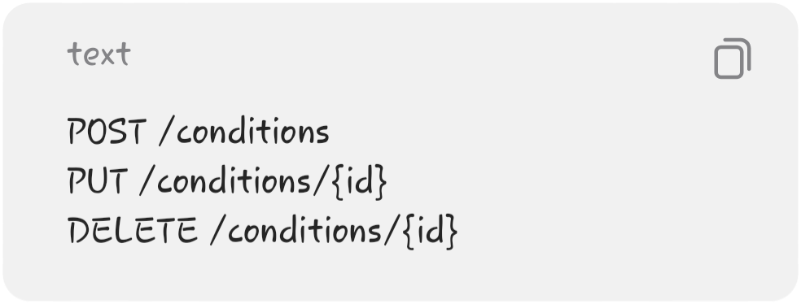
should require an authenticated administrator.

───
13. API Structure
I'd organize your endpoints like this:
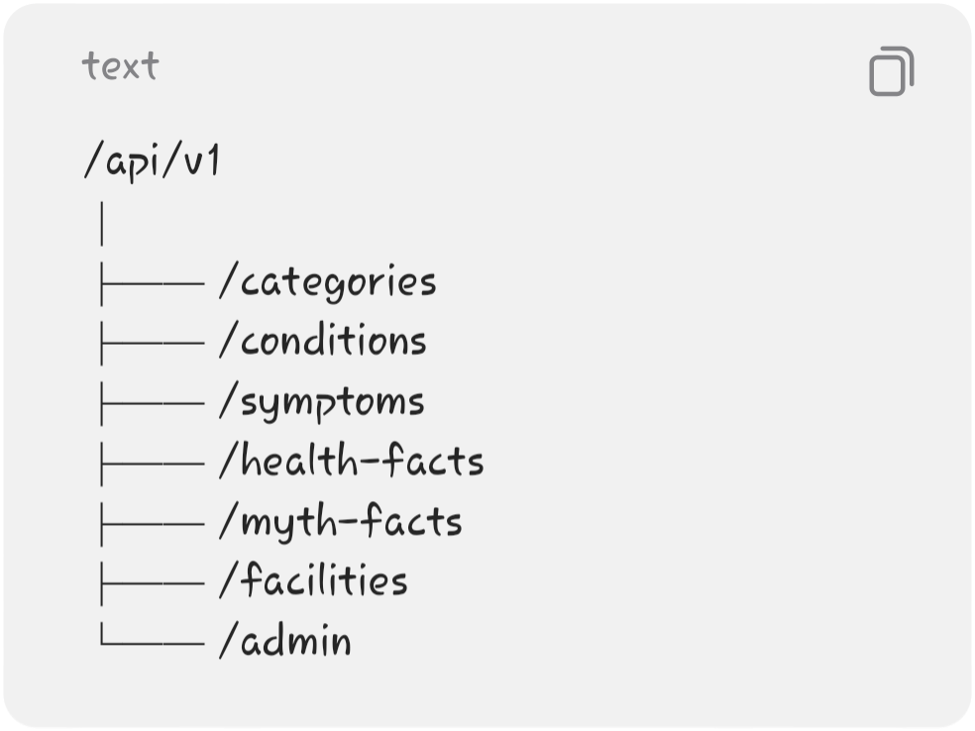

───

14. Category Endpoints
Get categories
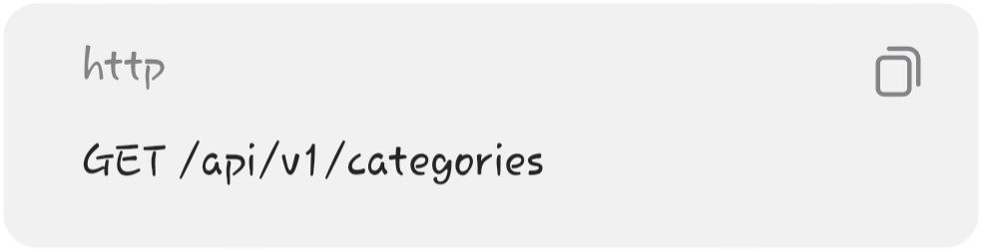
Returns all categories.
Get category
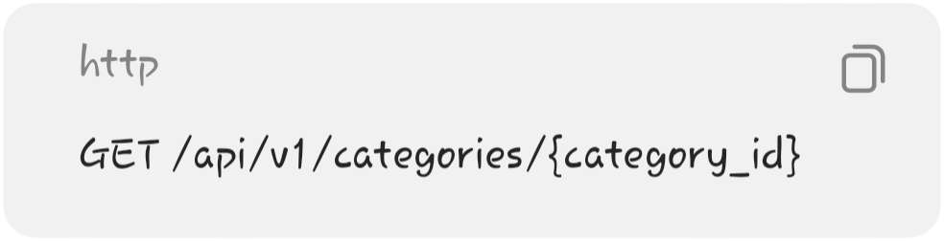
Returns one category.
Create category

Admin only.
Update category
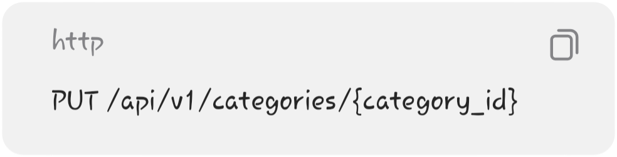
Admin only.
Delete category
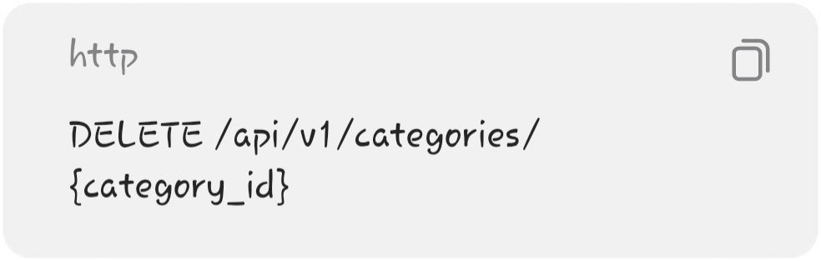
Admin only.

───
15. Condition Endpoints
These are some of the most important endpoints.
Get all conditions
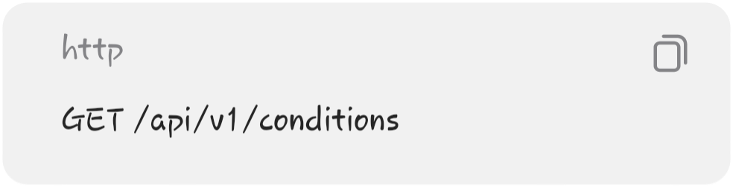
Used by:
Health Topics page

───

Get one condition
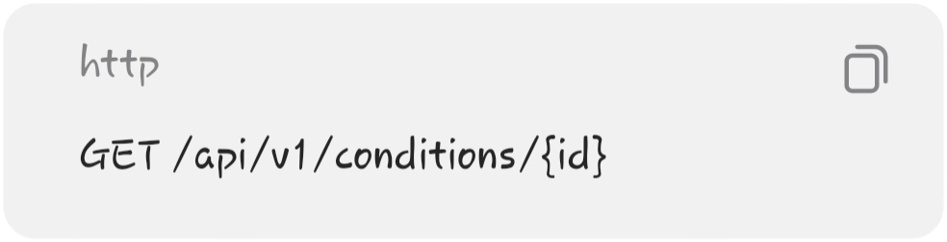
Used by:
Condition Details page

───

Filter by category
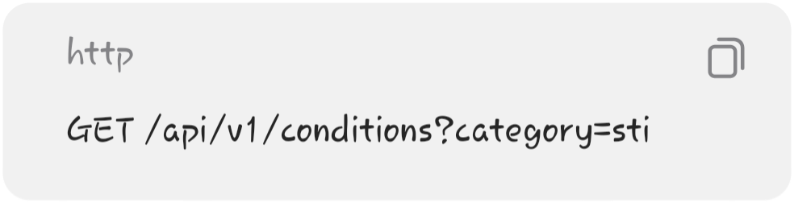
Used by:
Category filtering

───

Search conditions

Used by:
Search page

───

Create condition

Admin only.

───

Update condition
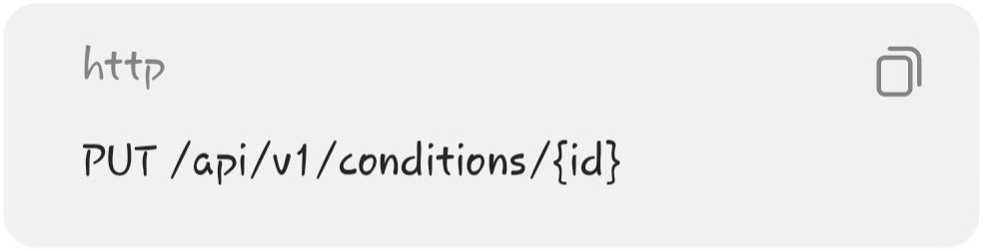
Admin only.

───

Delete condition

Admin only.

───

16. Symptoms Endpoints
Get all symptoms
Used by:
Symptoms & Health Check page

───

Get symptom
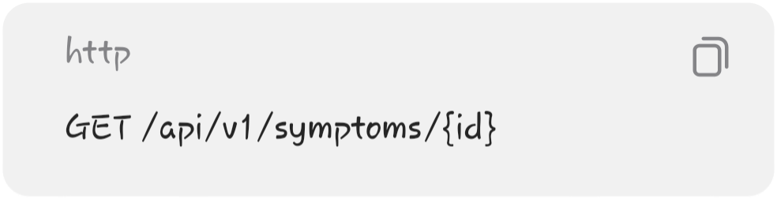

───

Get related conditions
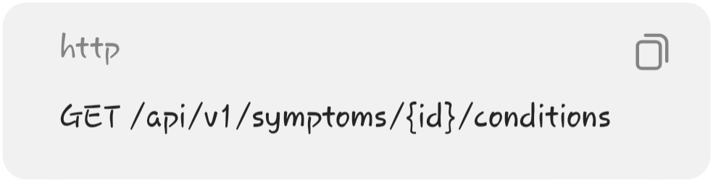
For example:
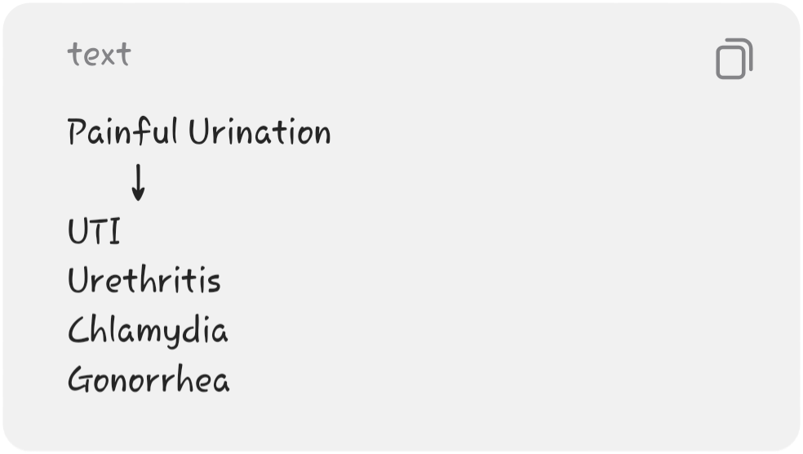
This endpoint is useful for connecting your learning content.

───

Admin CRUD
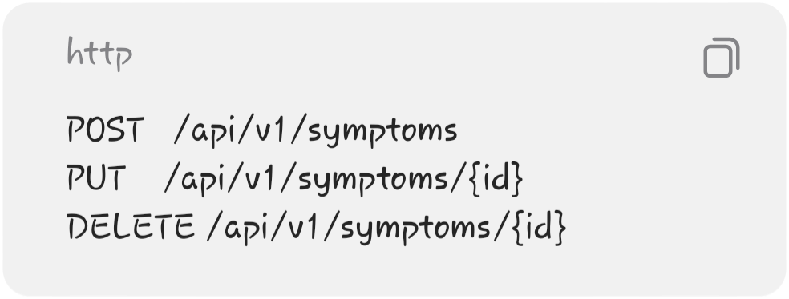
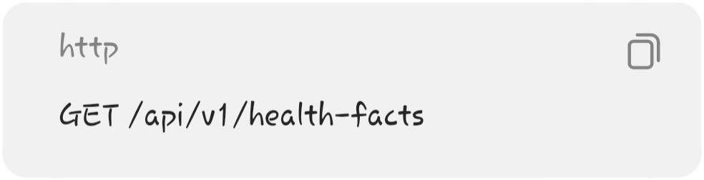
Admin only.

───

17. Health Facts Endpoints
Get facts
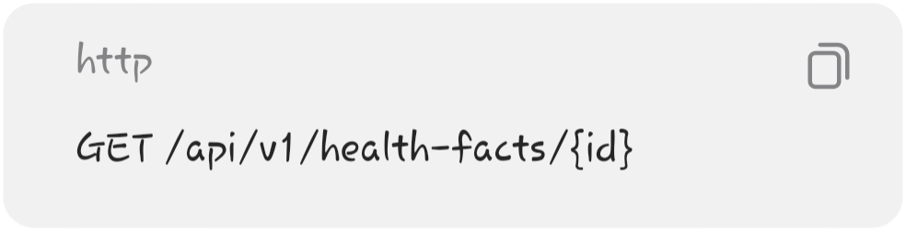
Get one fact

Add fact

Admin only.
Update fact
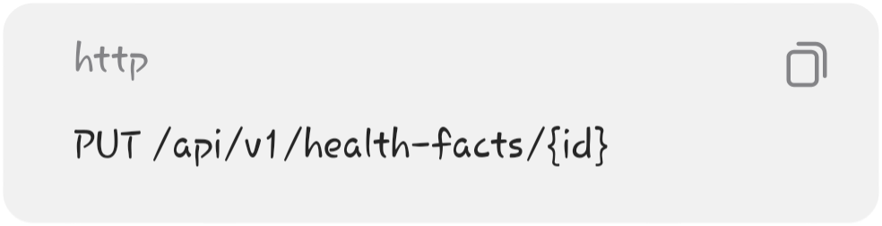
Admin only.
Delete fact
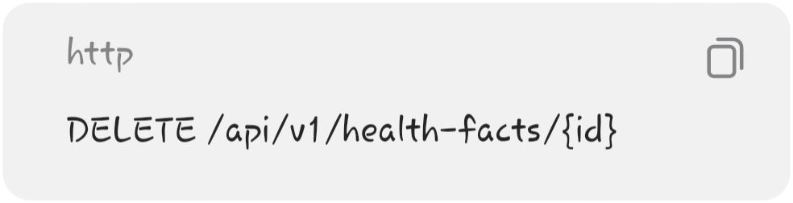
Admin only.
───

18. Myth vs Fact Endpoints
Get myths/facts
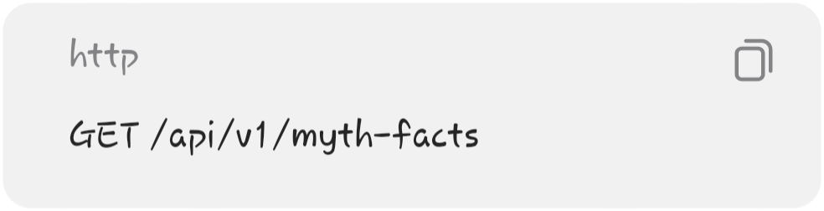
Get one
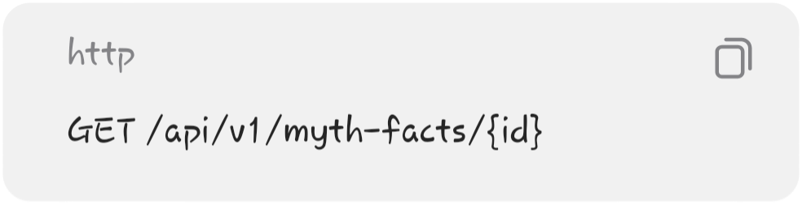
Create

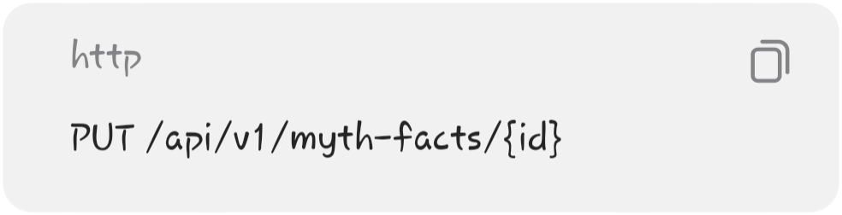
Admin only.
Update
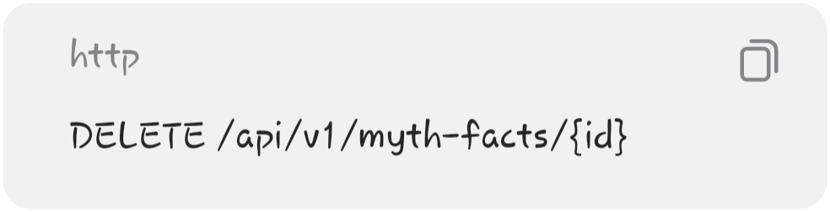
Admin only.
Delete

Admin only.

───

19. Healthcare Facility Endpoints
Get facilities
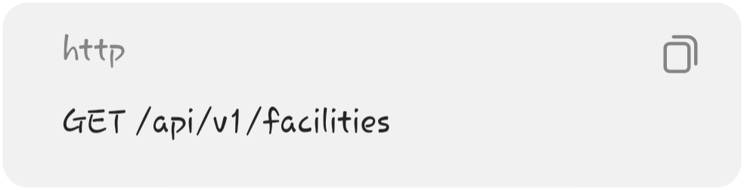
Used by:
Healthcare Services page

───

Get facility
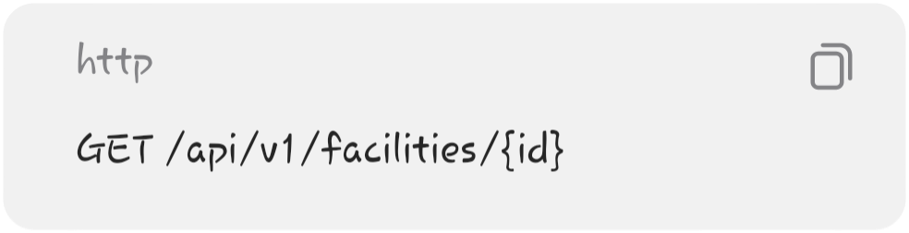
Used by:
Facility Details page
───

Search facilities


───

Filter by service
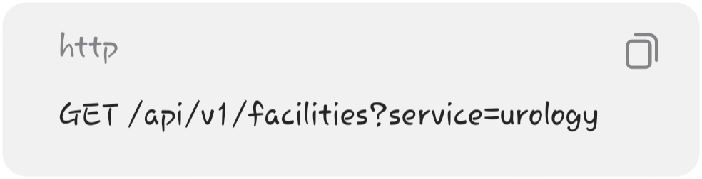

───
Create facility

Admin only.

───

Update facility
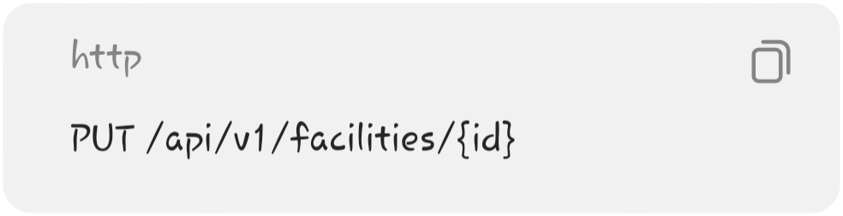
Admin only.

───
Delete facility

Admin only.

───

20. Search API
You can make search simple for the MVP.
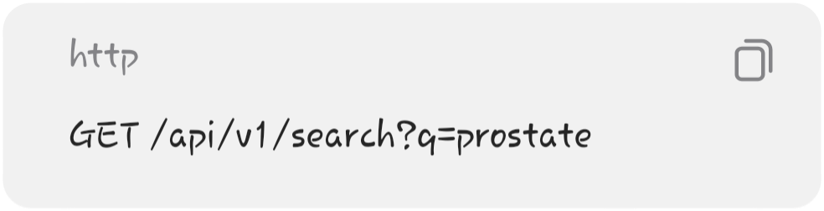
The backend can search:
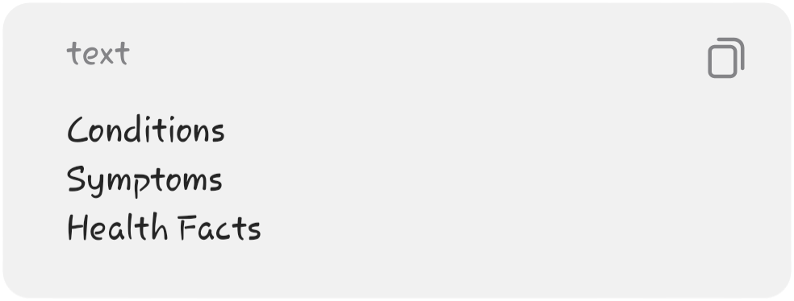
and return:
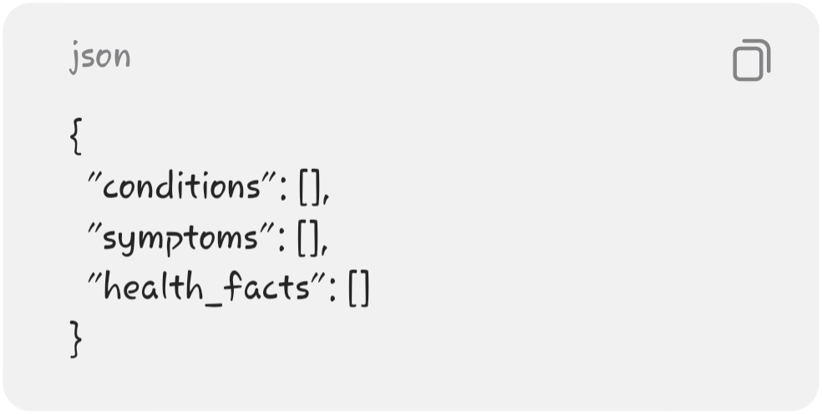
You don't need Elasticsearch or another search engine.
Simple PostgreSQL text matching is enough.

───
21. Backend Folder Structure
I recommend this structure:

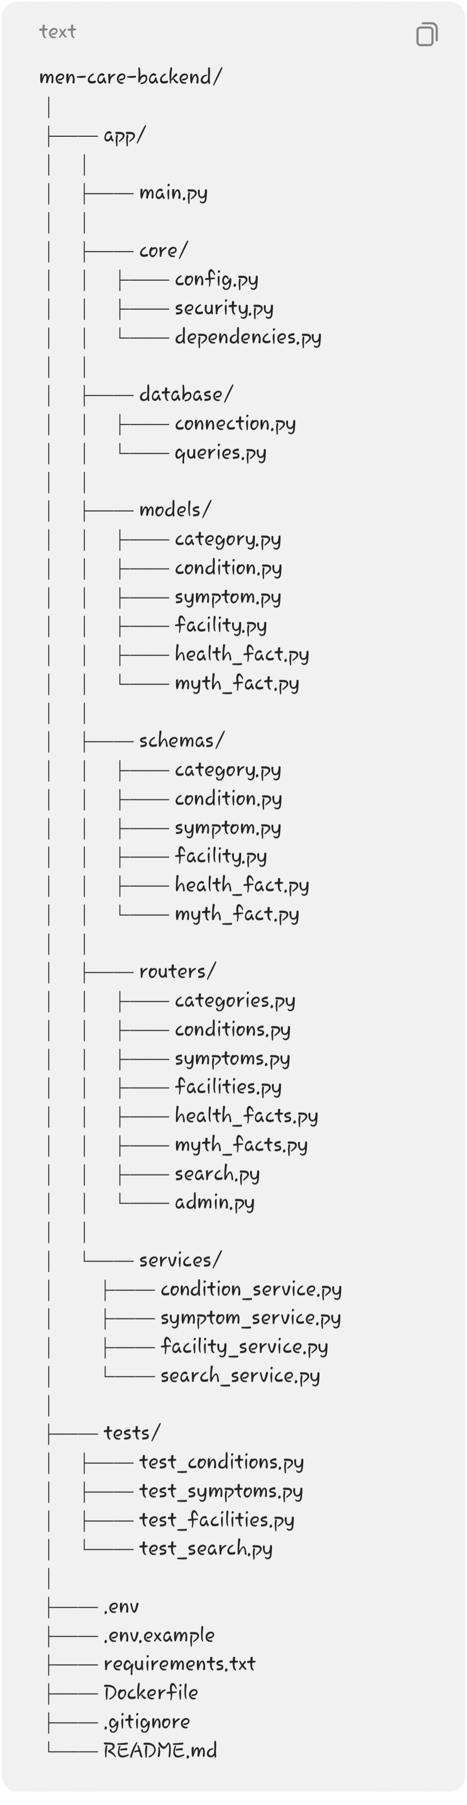

───

22. What Each Backend Folder Does
main.py
Starts FastAPI and registers your routers.
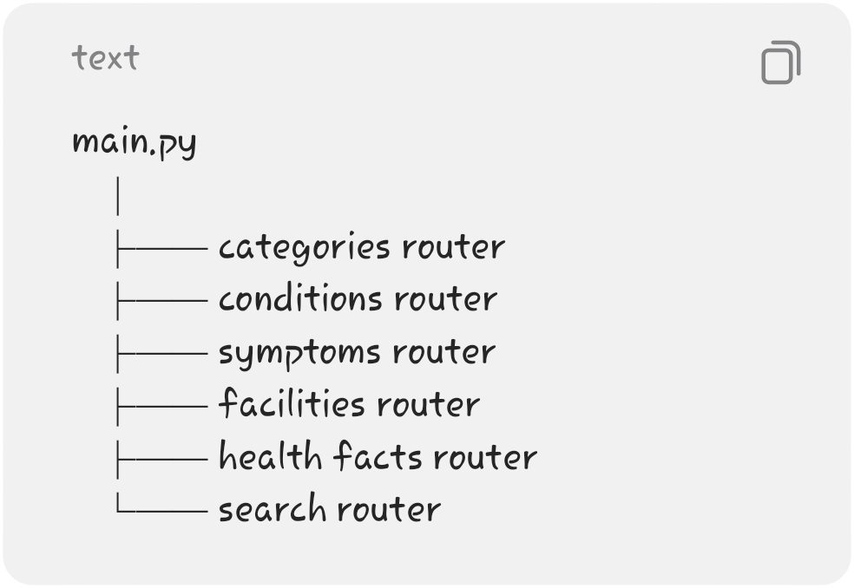

───

core/
Contains system-wide configuration and security.
For example:

stores environment settings.

handles JWT verification and authentication-related functionality.

contains reusable dependencies such as:


───

database/
Handles communication with Supabase.
For your project, you can use the Supabase Python client rather than making the database layer unnecessarily complicated.

───

models/
Represents your data structures.
For example:
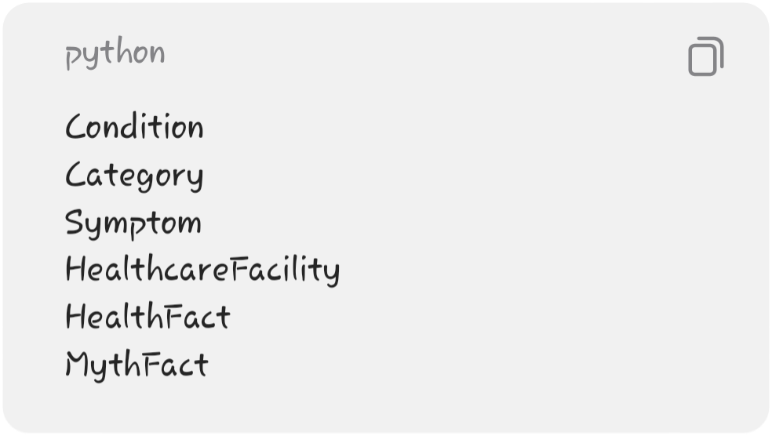
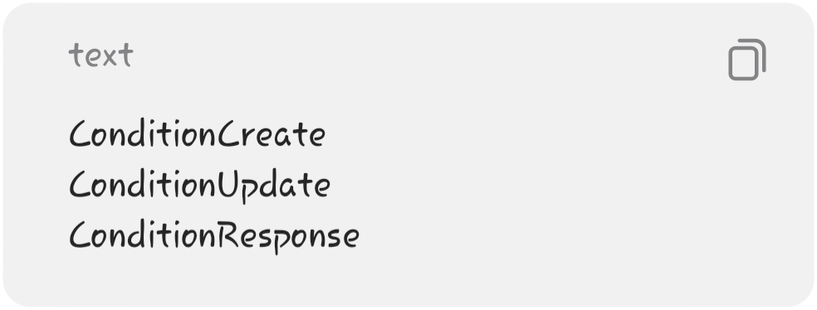

───

schemas/
Pydantic models used to validate API input/output.
For example:

This is important because it demonstrates Pydantic validation, which is a major FastAPI concept.
───

routers/
Contains your actual API endpoints.
For example:

contains:
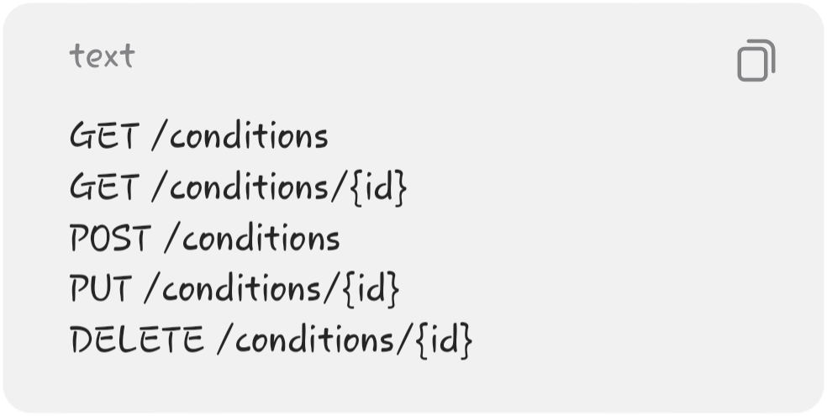
───

services/
Contains reusable business logic.
For example:

could handle:
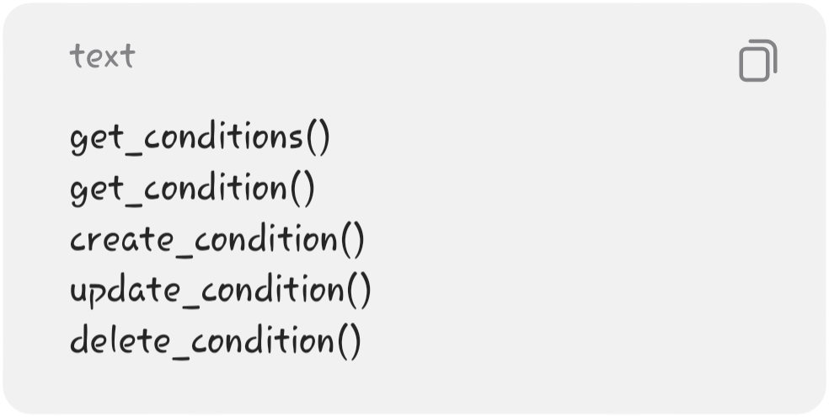
This prevents your route files from becoming huge.

───

23. API Response Example
When the frontend requests:
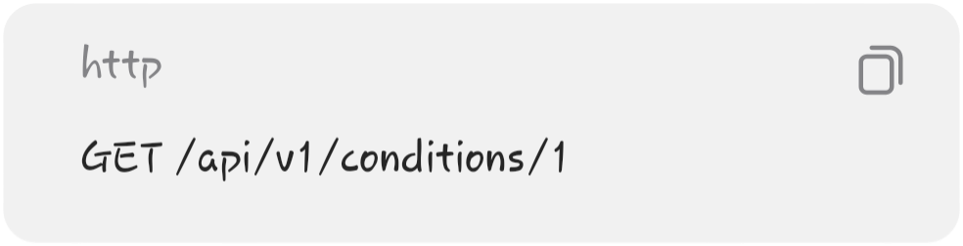
FastAPI could return:

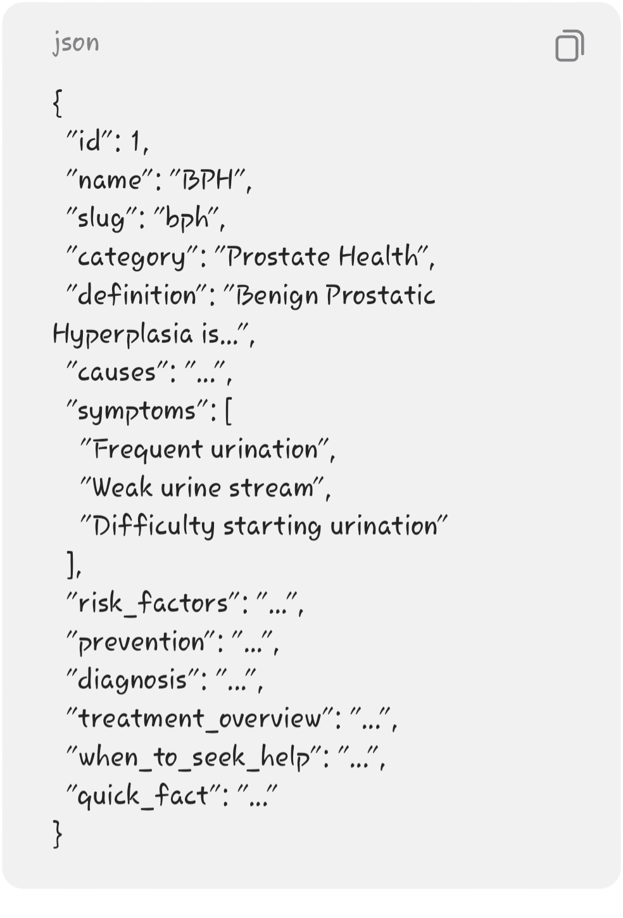
The React frontend simply displays this information.

───

24. Frontend ↔ Backend Mapping
This is important for your project documentation.

Frontend Page | API Endpoint
Home | /conditions, /health-facts
Health Topics | /conditions, /categories
Condition Details | /conditions/{id}
Symptoms | /symptoms
Symptom Details | /symptoms/{id}/conditions
Search | /search?q=
Healthcare Services | /facilities
Facility Details | /facilities/{id}
Health Facts | /health-facts
Myth vs Fact | /myth-facts
Admin Dashboard | Multiple management endpoints
Manage Conditions | /conditions
Manage Facilities | /facilities
Manage Facts | /health-facts
Manage Myth/Fact | /myth-facts

───

25. Security
Keep security appropriate for your MVP.
Public endpoints
These can be accessed without authentication:
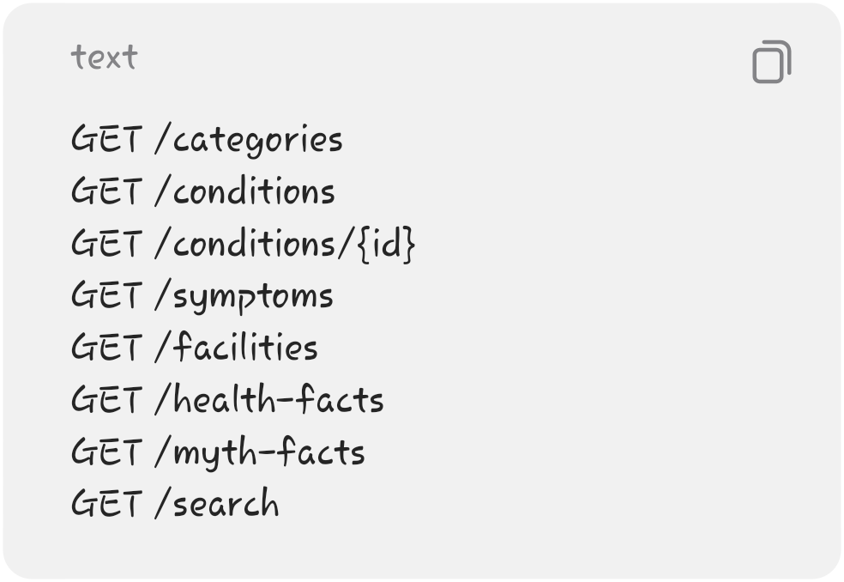
Protected endpoints
These require an authenticated administrator:

for your content and facility resources.

───

26. Supabase RLS
Supabase Row-Level Security should protect your database.
Conceptually:

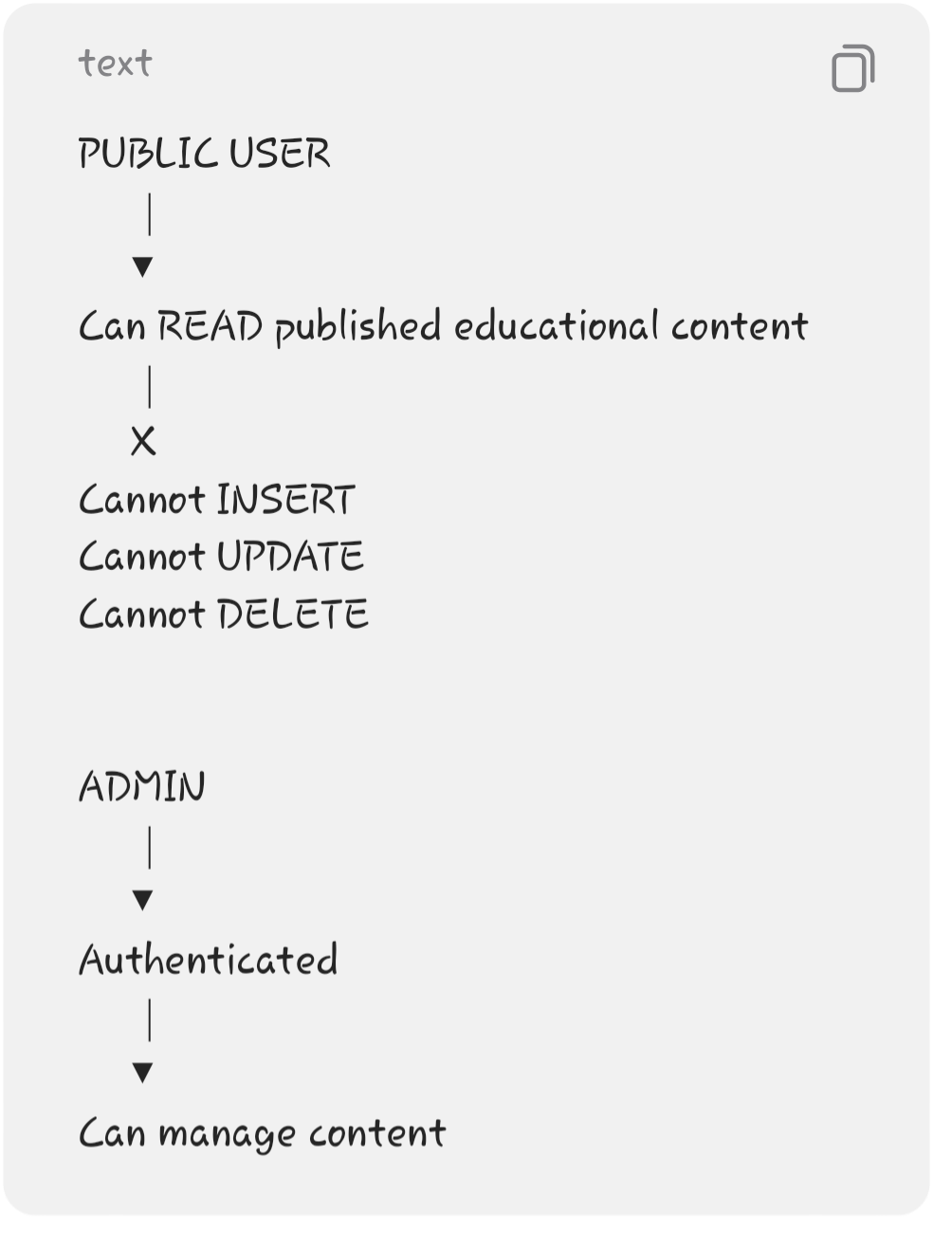
This gives you a good security component for your academic project without building a complicated authorization system yourself.

───
- 27. Error Handling
- Your FastAPI backend should return proper HTTP responses.
- Examples:
- Condition doesn't exist

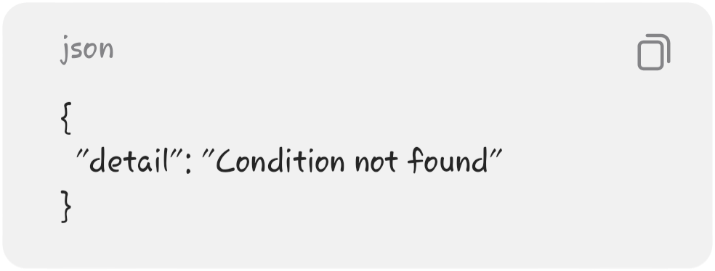
Invalid input
FastAPI/Pydantic can handle much of this automatically.
Unauthorized admin

Forbidden action


───

28. Validation
Pydantic should validate fields before they reach
your database.
For example:
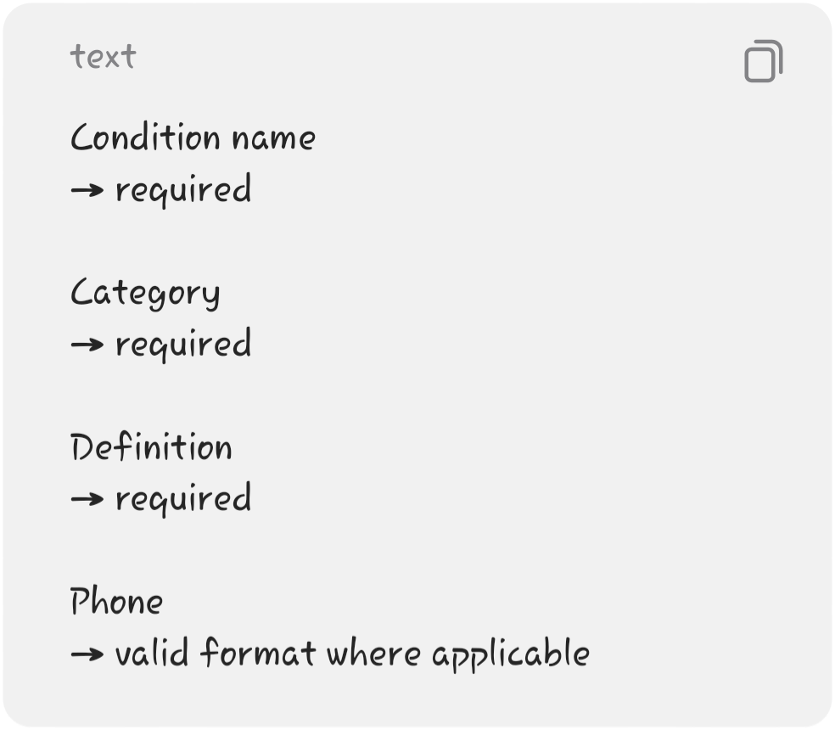
You should also prevent:
Empty condition names
Invalid IDs
Missing required fields
Extremely long inappropriate input

───

29. Backend MVP — What You Actually Need to Build
Don't implement everything at once.
Phase 1 — Database
Build:
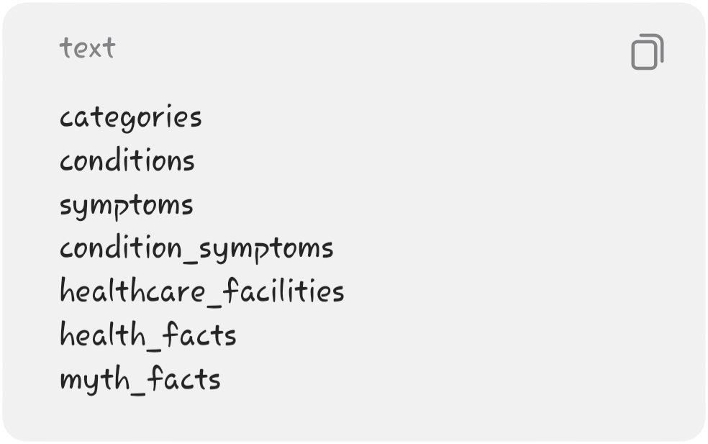
Populate your initial 7 conditions.

───

- Phase 2 — FastAPI Setup
- Create:
- 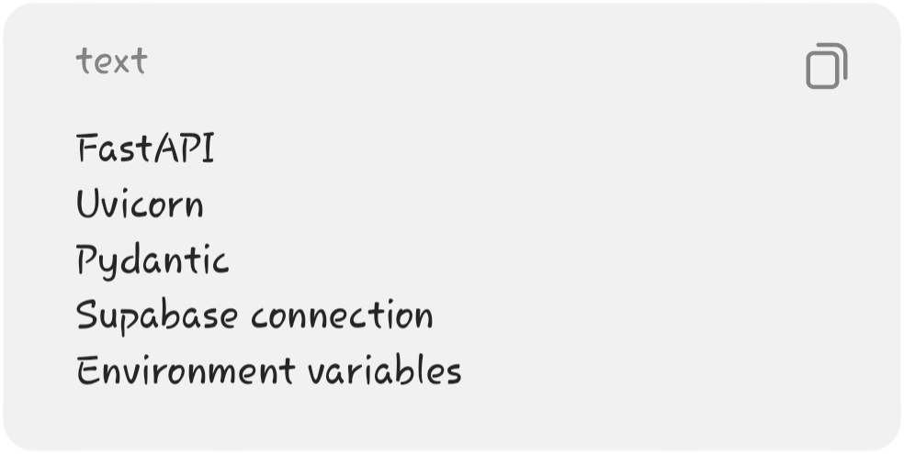
- Then test:

Response:
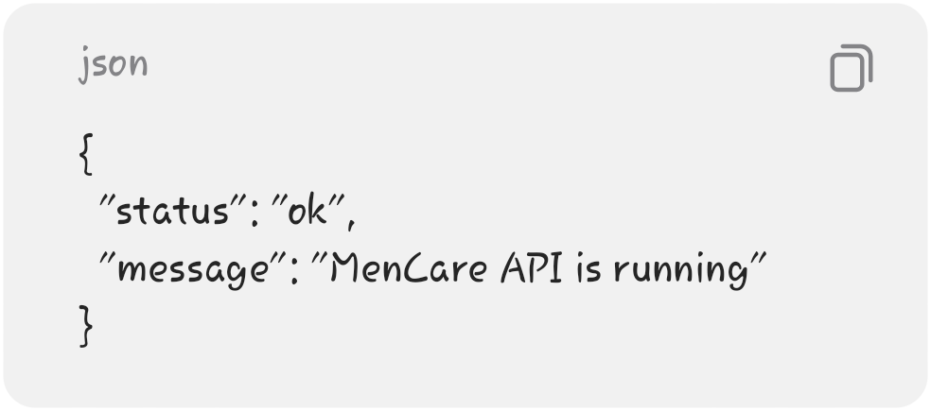

───

Phase 3 — Education API
Build:
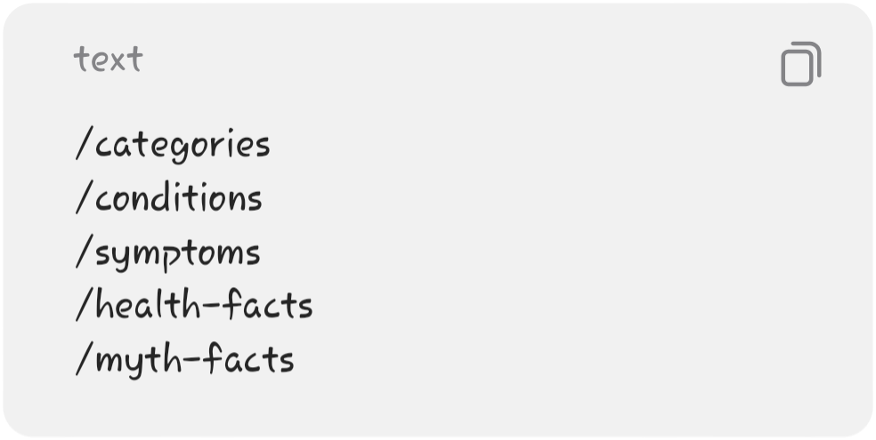
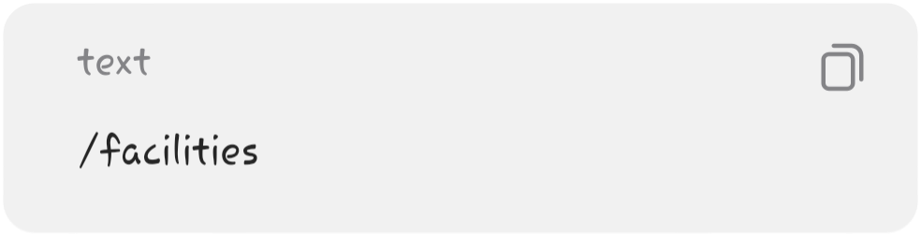
Get the public website working first.

───

Phase 4 — Healthcare API
Build:

Add:
Search
Location filtering
Service filtering
Facility details

───

Phase 5 — Search
Implement:

Don't over-engineer it.

───

Phase 6 — Authentication
Implement:
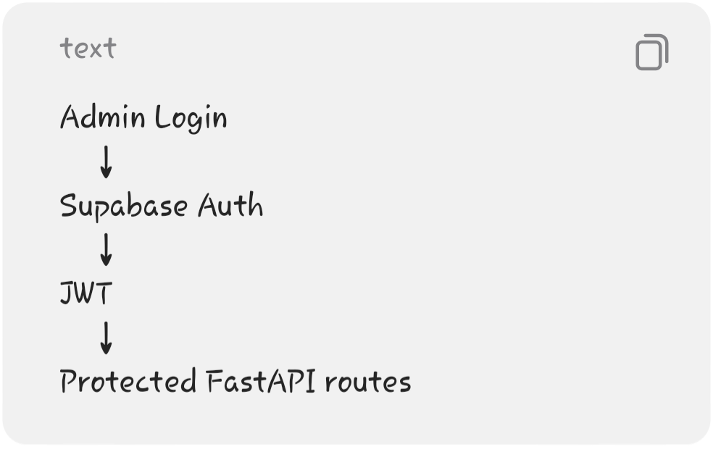
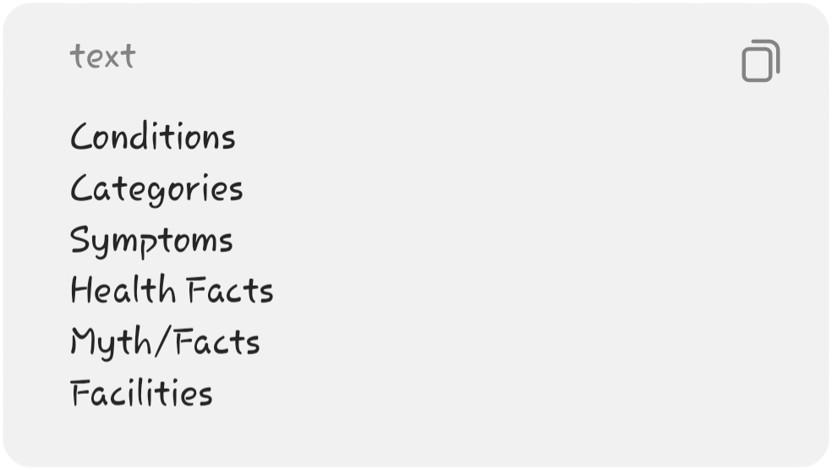

───

Phase 7 — Admin CRUD
Implement:

with:
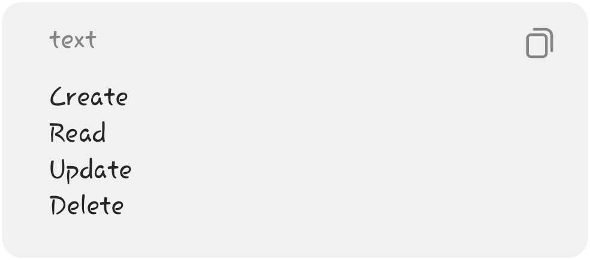

───

Phase 8 — Testing
Test:
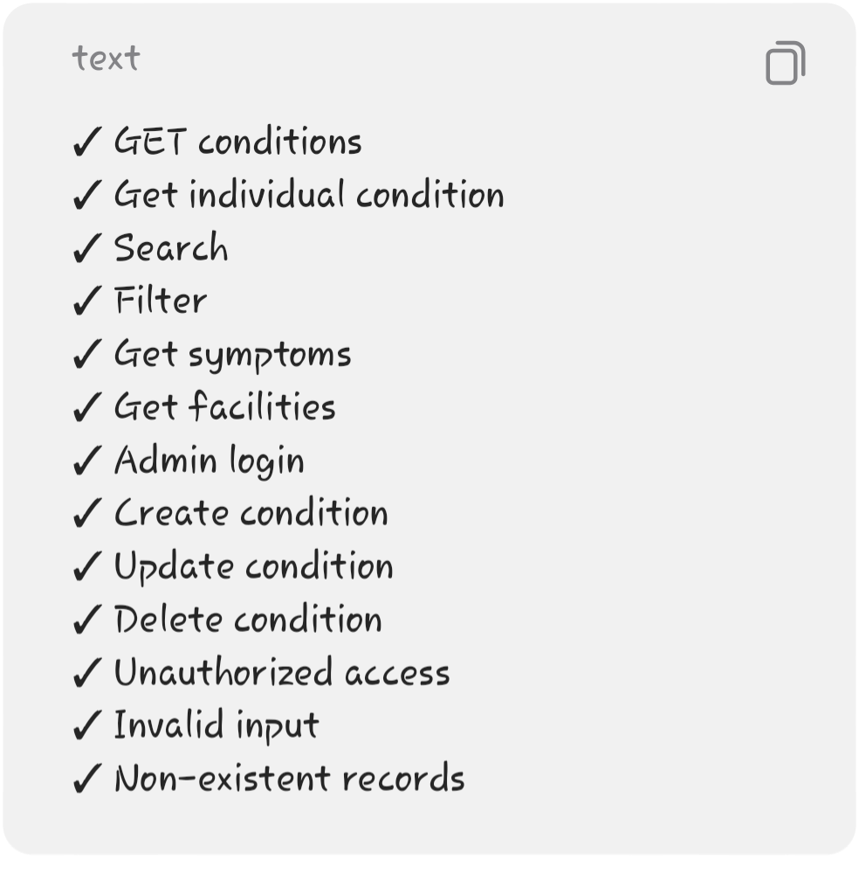

───

30. Final Backend Architecture
Your complete MVP can therefore be summarized as:

